This query uses an INNER JOIN to fetch usernames along with their corresponding order IDs by matching records from the users and orders tables using user_id.
Only users who have placed orders are included in the result, which demonstrates how INNER JOIN returns matched records from both tables.

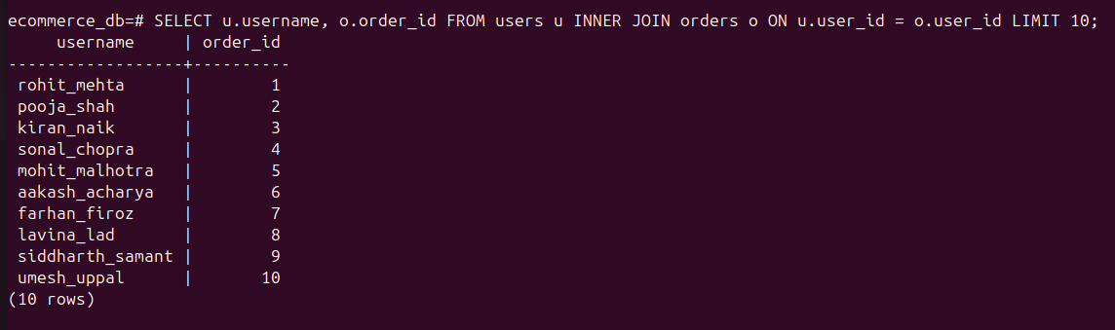

This query uses a LEFT JOIN to retrieve user account details along with their profile information by joining the users and user_profile tables on user_id.
All users are included in the result, even if their profile details do not exist, in which case the profile columns return NULL. This demonstrates how LEFT JOIN handles unmatched records.

